04 Feb 2004

Daniel EGIOLE
f5iki@wanadoo.fr

After replacement of the power transistors result a bad continuity in the rotary switch, I decided to suppress it.

The modification is made with 14 relays, and a logic control, any modification outside the filter block.

The silence is now very appreciable, any perturbations on the logic control during transmission.

Construction:

Some component are moved on the PCB logic control (see photos)

L15 is moved too.

For a short connection between filters and relays PCB, is necessary to cut some tracks on the PCB filters.

The relays used are made by Goodsky, model GS SH 212T. A lot of relays with the same size, pin assignment and resistance > 700 Ω can be used.
Schematic diagram
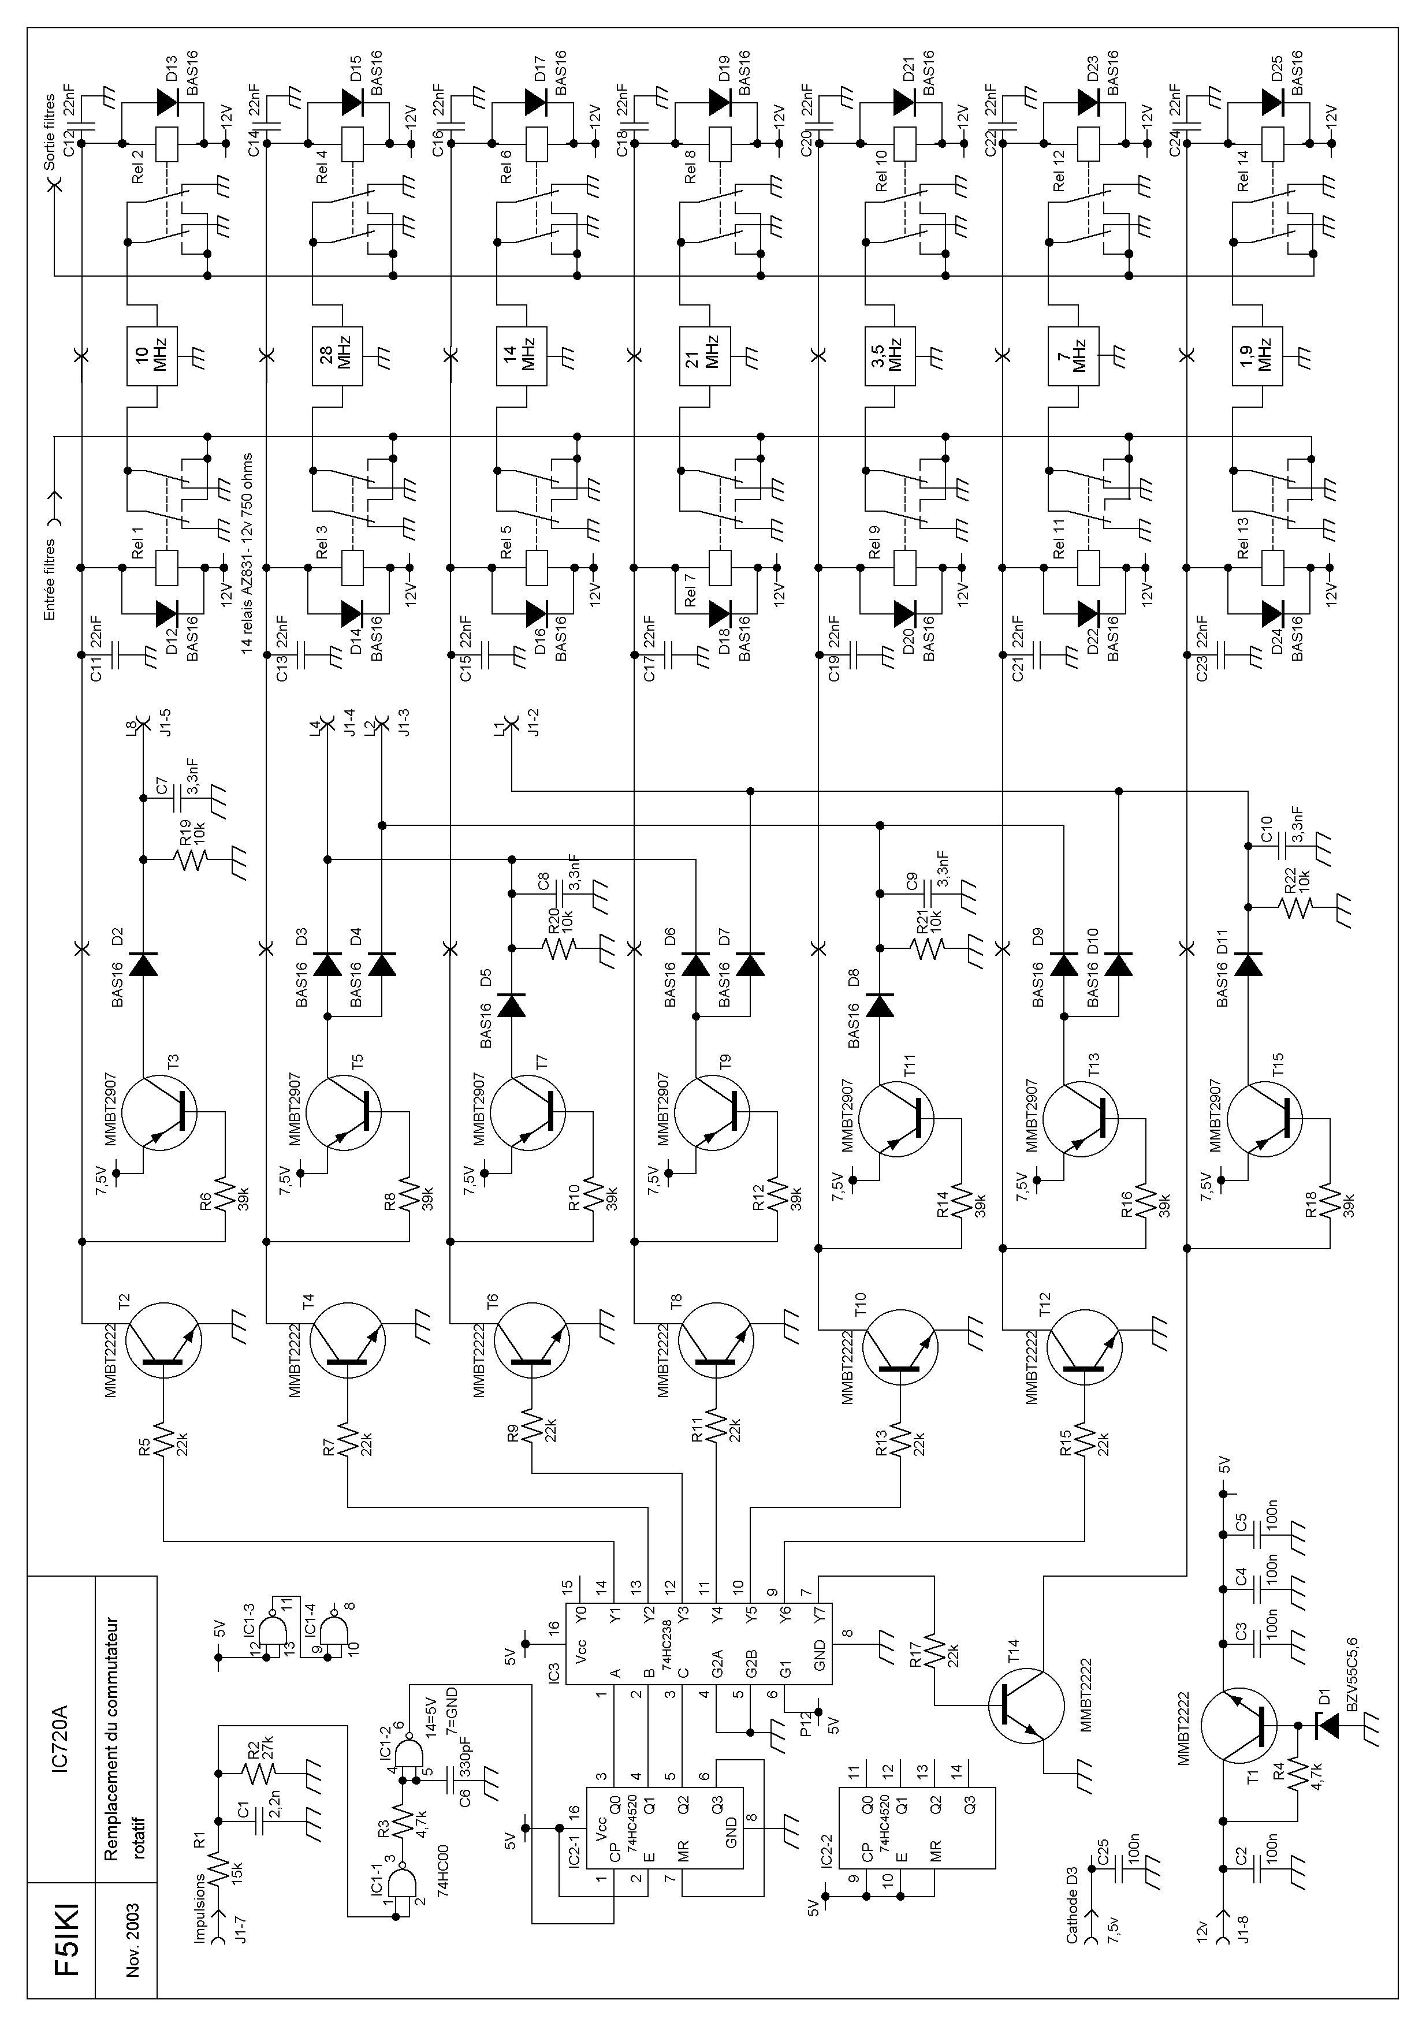
View of logic control

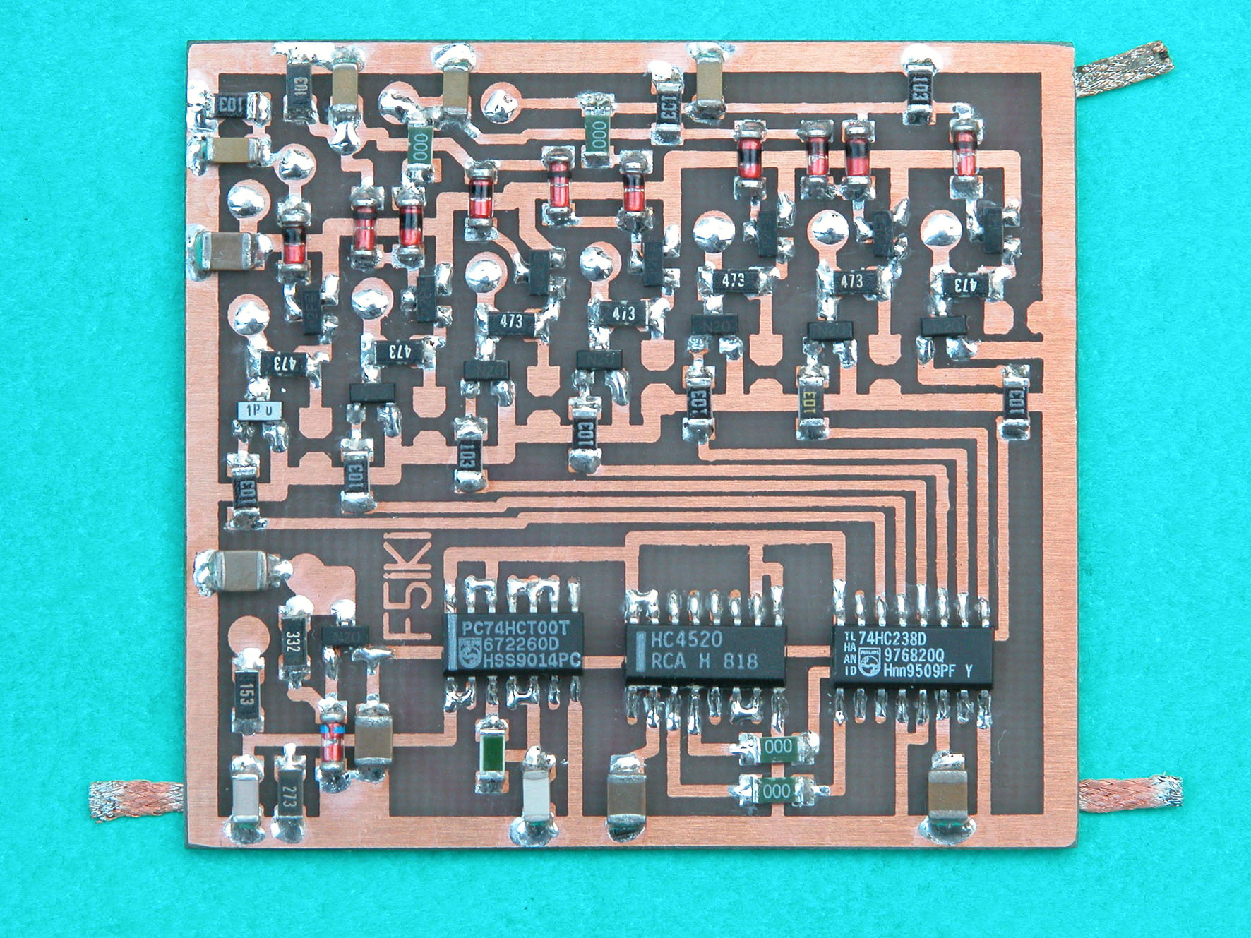
In the filter block
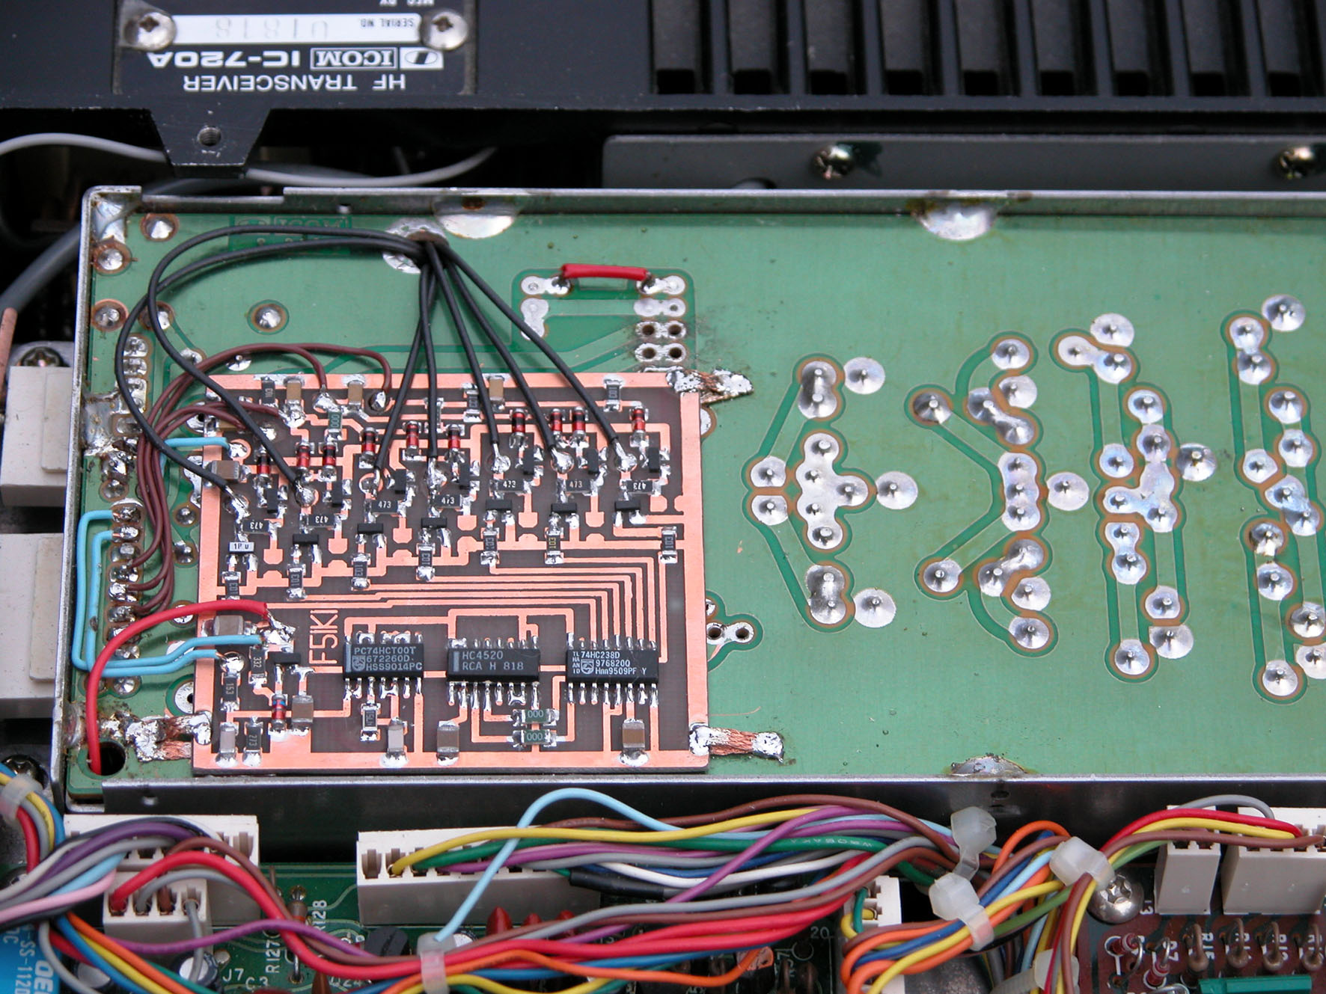
View relays 1
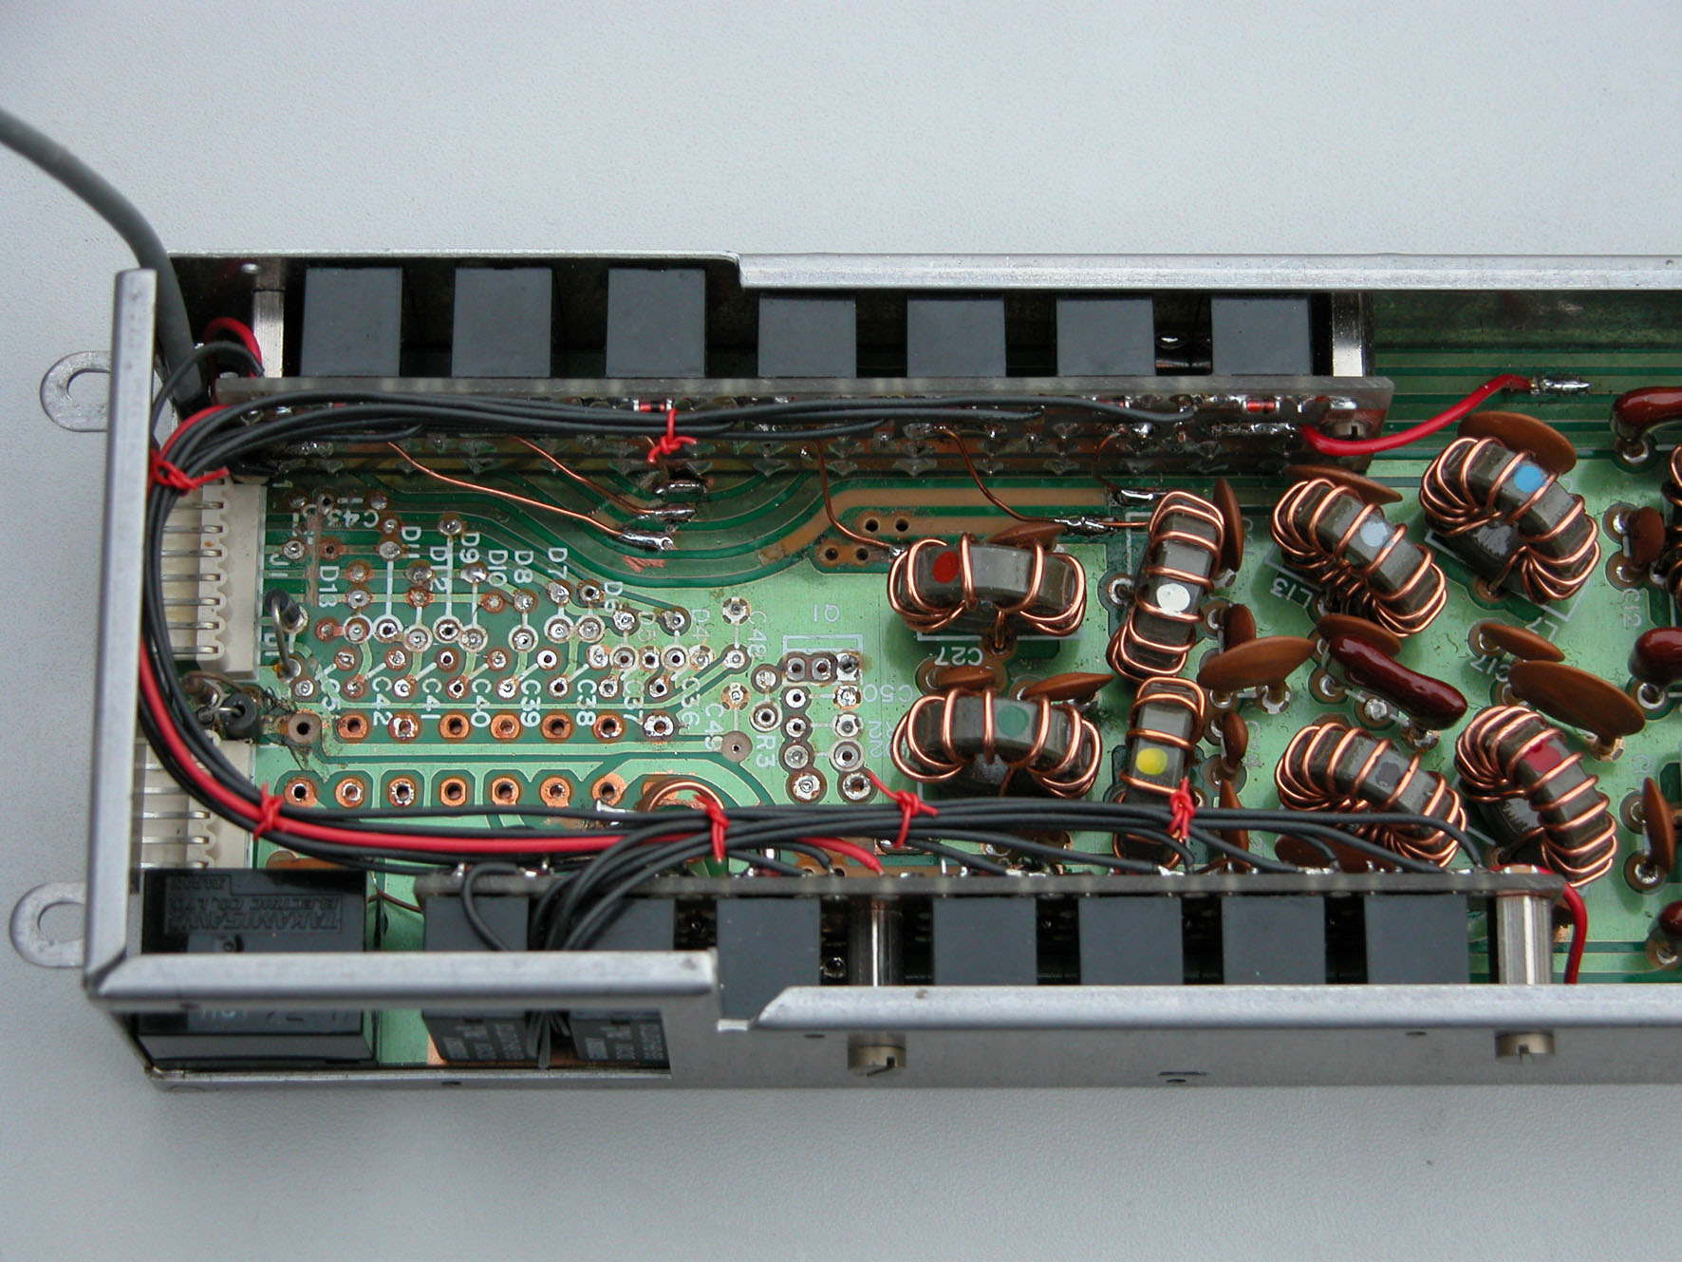
2
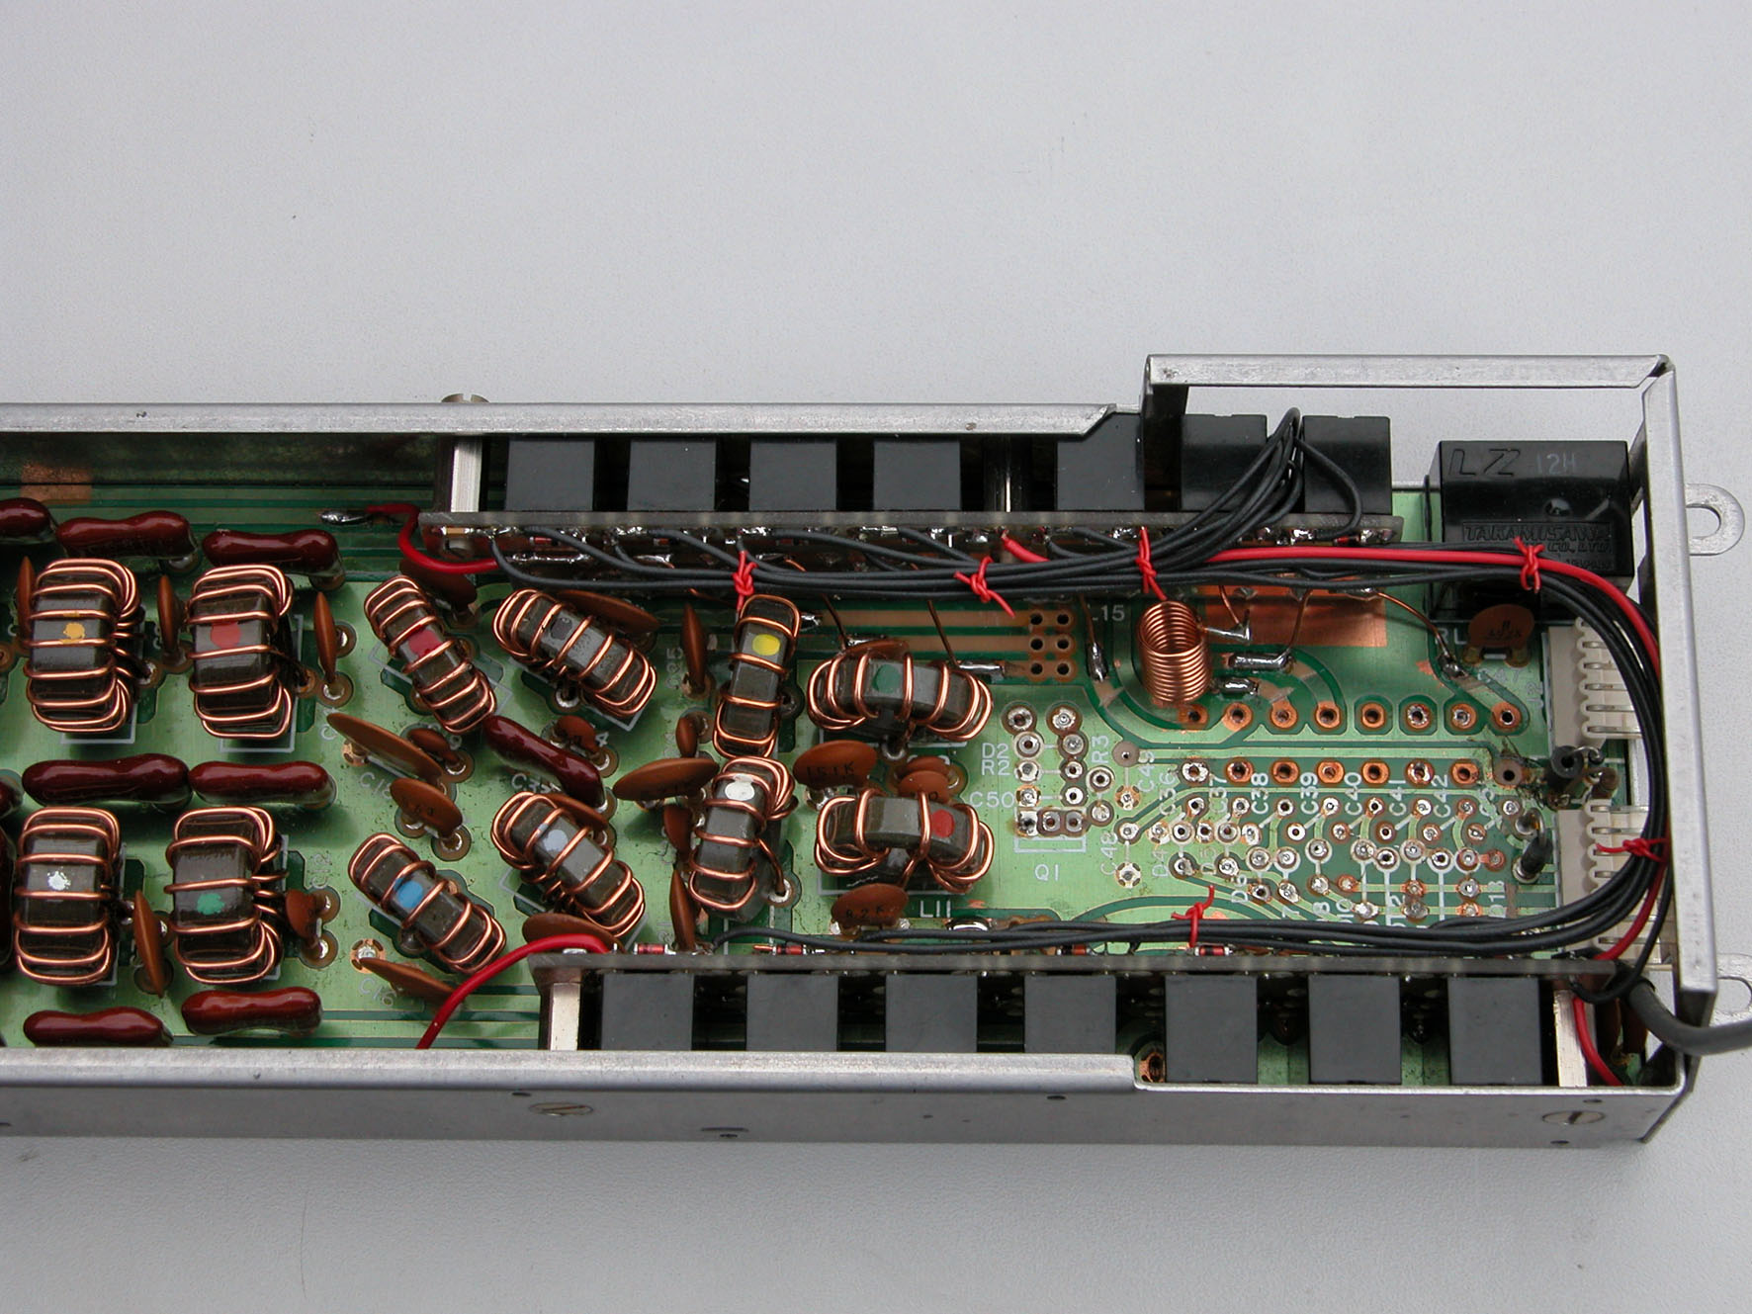
3
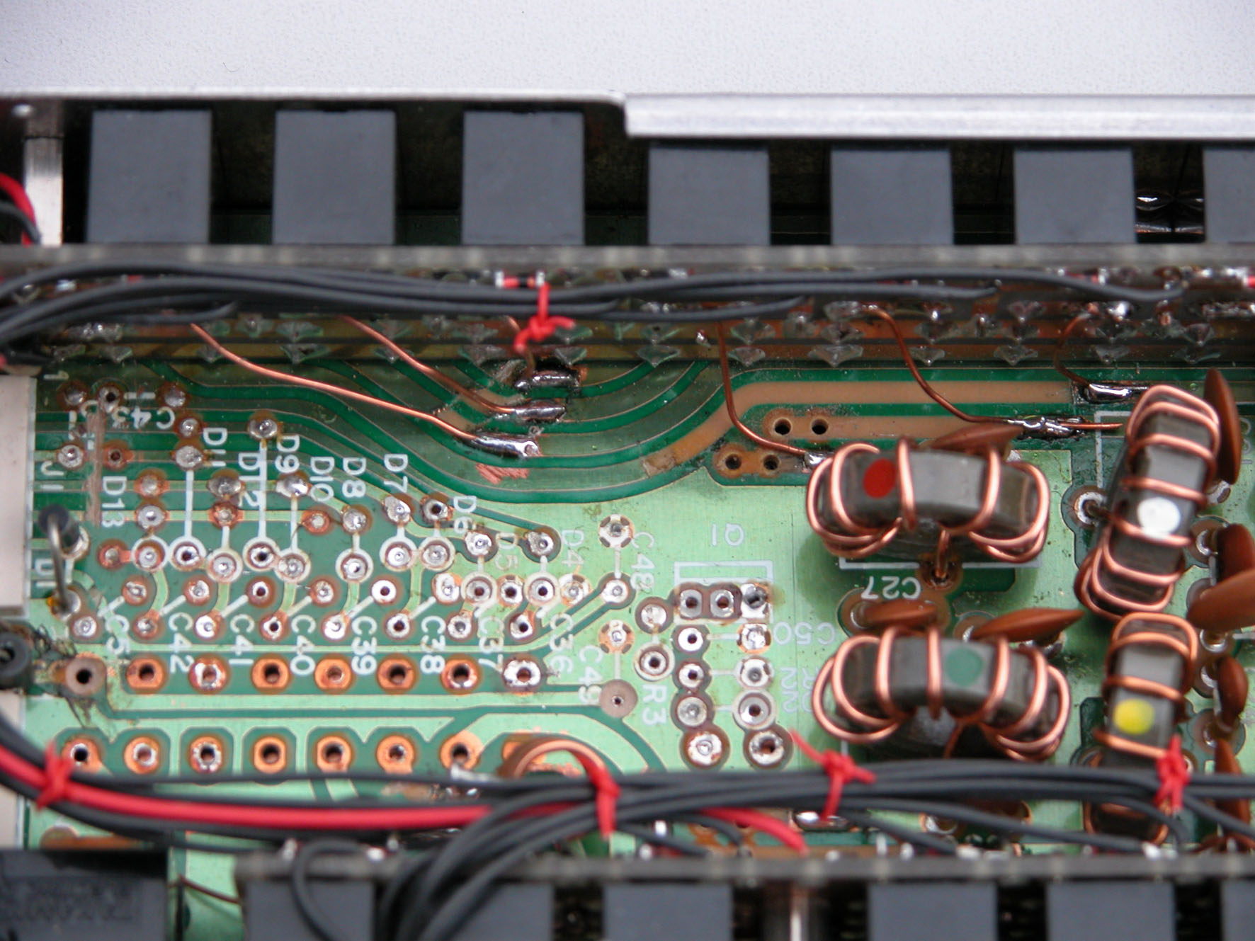
4
